October 1, 2021

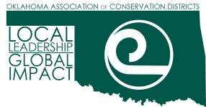

The Oklahoma Association of Conservation Districts is a non-profit dedicated to providing leadership, resources, and partnership opportunities for conservation districts and those who manage the land to enhance our natural resources for a better Oklahoma. We are searching for a Project Manager to assist with our Conservation and Agriculture Reach Everyone (CARE) program. This is a key position that develops and maintains best practices to increase the number of socially disadvantaged and veteran farmers and ranchers participating in conservation programs. Candidates must have a bachelor’s degree and a minimum of three years’ experience in grant management, administration, or development.

This position is remote and offers a contract salary of $55,000 for one year with potential renewal for subsequent years. If interested, please send a resume and a one page writing sample to [sarahblaney@okconservation.org](mailto:sarahblaney@okconservation.org)

Please visit okconservation.org/care for more information about the program.

We promote diversity of thought, culture and background, which connects the entire conservation family. As such, OACD is proud to be an Equal Opportunity Employer. We do not discriminate on the basis of race, color, ancestry, national origin, religion or religious creed, mental or physical disability, medical condition, genetic information, sex (including pregnancy, childbirth, and related medical conditions), sexual orientation, gender identity, gender expression, age, marital status, military or veteran status, citizenship, or other characteristics protected by state or federal law or local ordinance.

Sincerely,



Sarah Blaney

Executive Director